**Q. Write a Problem Analysis Chart (PAC), Algorithm and Flowchart for finding the roots of a quadratic equation.**

PAC

|  |  |  |  |
| --- | --- | --- | --- |
| **Data** | **Processing** | **Output** | **Solution Alternatives** |
| Coefficient of (x^2), a  Coefficient of x, b  Constant, c | X1 = ((-b) – (sqrt((b^2) – (4 * a * c))) / (2 * a)  X2 = ((-b) + (sqrt((b^2) – (4 * a * c))) / (2 * a) | Print X1 and X2 |  |

Algorithm

* Start
* Use variable **a**, **b**, **c**, **X1**, **X2**
* Read **a**, **b**, **c**
* Calculate **X1** = ((-**b**) – (sqrt((**b**^2) – (4 * **a** * **c**))) / (2 * **a**)
* Calculate **X2** = ((-**b**) – (sqrt((**b**^2) + (4 * **a** * **c**))) / (2 * **a**)
* Print **X1**, **X2**
* Stop

Flowchart

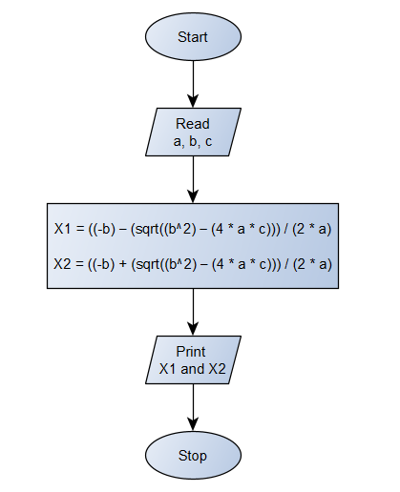

Python Program

import math  
print(**"The format of the quadratic equation is :** \n**"  
 "ax^2 + bx + c = 0** \n**"  
 "where, a is not equal to 0"**)  
a = float(input(**"Enter the value of a : "**))  
b = float(input(**"Enter the value of b : "**))  
c = float(input(**"Enter the value of c : "**))  
D = (b**2) - (4 * a * c) *# D = Discriminant*eq = **"("** + str(a) + **")x**2 + "** + str(b) + **"x + "** + str(c) + **" = 0"**if (D < 0):  
 print(**"There are no real solutions for the equation : "**, eq, **"**\n**"  
 "Therefore, the imaginary solutions are :** \n**"  
 "X1 = "**, (-b/(2*a)), **"+ i"**, (math.sqrt(abs(D))/(2*a)), **"**\n**"  
 "X2 = "**, (-b/(2*a)), **"- i"**, (math.sqrt(abs(D))/(2*a)))  
elif (D==0):  
 x1 = ((-b) - math.sqrt(D)) / (2 * a)  
 print(**"The solutions for the equation :"**, eq, **"are"**, x1, **"and"**, x1)  
else:  
 x1 = ((-b) - math.sqrt(D)) / (2 * a)  
 x2 = ((-b) + math.sqrt(D)) / (2 * a)  
 print(**"The solutions for the equation :"**, eq, **"are"**, x1, **"and"**, x2)